Technical Specification-
1.
ASSA ABLOY MAKE TELESCOPIC DOCK LEVELER DL6121T 150kN
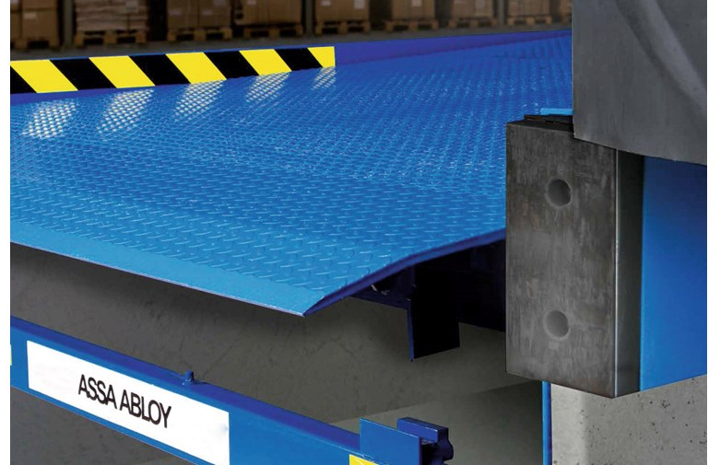

Sr. No | Description | Specifications
1 | Nominal Width | 2000 mm
2 | Nominal Length | 3000 mm
3 | Leveler Height | 800 mm
4 | Load Capacity | 150 kN
5 | Leveler Surface Treatment | RAL 5010 (Gentian Blue)
6 | Leveler Paint class | 80 μm
7 | Lip Material | Steel
8 | Lip Length | 1000 mm
9 | Tearplate Thickness | 10 mm
10 | Control Box | 950 LA
11 | Free space under lip | 285
12 | Lip Bevellment | 40 mm
13 | Control System | Mains Switch
2.
ASSA ABLOY MAKE SWING DOCK LEVELER DL6111S 200kN

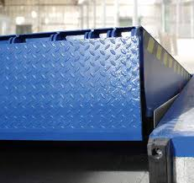
SIZE - (W) 2000 mm x (L) 2500 mm

Sr. No | Description | Specifications
1 | Nominal Width | 2000 mm
2 | Nominal Length | 2500 mm
3 | Leveler Height | 700 mm
4 | Load Capacity | 200 kN
5 | Leveler Surface Treatment | RAL 5010 (Gentian Blue)
6 | Leveler Paint class | 80 μm
7 | Lip Material | Steel
8 | Lip Length | 500 mm
9 | Tearplate Thickness | 10 mm
10 | Control Box | 950 LA
11 | Free space under lip | 230
12 | Lip Bevellment | 40 mm
13 | Control System | Mains Switch
SIZE - (W) 2200 mm x (L) 3000 mm

Sr. No | Description | Specifications
1 | Nominal Width | 2200 mm
2 | Nominal Length | 3000 mm
3 | Leveler Height | 750 mm
4 | Load Capacity | 200 kN
5 | Leveler Surface Treatment | RAL 5010 (Gentian Blue)
6 | Leveler Paint class | 80 μm
7 | Lip Material | Steel
8 | Lip Length | 500 mm
9 | Tearplate Thickness | 10 mm
10 | Control Box | 950 LA
11 | Free space under lip | 230
12 | Lip Bevellment | 40 mm
13 | Control System | Mains Switch

SIZE - (W) 2200 mm x (L) 4000 mm

Sr. No | Description | Specifications
1 | Nominal Width | 2200 mm
2 | Nominal Length | 4000 mm
3 | Leveler Height | 900 mm
4 | Load Capacity | 200 kN
5 | Leveler Surface Treatment | RAL 5010 (Gentian Blue)
6 | Leveler Paint class | 80 μm
7 | Lip Material | Steel
8 | Lip Length | 500 mm
9 | Tearplate Thickness | 10 mm
10 | Control Box | 950 LA
11 | Free space under lip | 230
12 | Lip Bevellment | 40 mm
13 | Control System | Mains Switch

